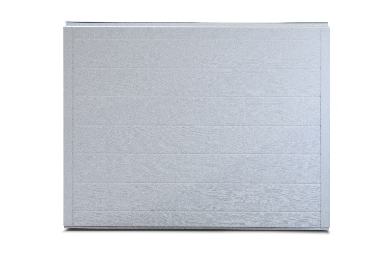

PRODUCT SPECIFCATION SHEET

**SERIES STANDARD FEATURES**

* Heavy Duty construction
* Thermally broken construction
* 2” Polyurethane injected foam core with R-value = 17.68
* Standard raised panel design
* 20 gauge painted end stiles
* Continuous vertical backer
* Commercial hardware
* Bracket mounted track
* 10 ball steel rollers
* 2” track (3” track available)
* Torsion spring counterbalance
* Aluminum & vinyl loop weather seal
* Limited lifetime warranty

**MODEL FEATURES**

* 27 gauge steel interior & exterior skins
* Woodgrain embossed texture
* 2” Thick Sections
* Tongue & Groove meeting joints
* Sizes up to 18’-2” wide & 16’ high
* White interior

*AMBIENT RESIDENTIAL SERIES*

**MODEL 273 STEEL INSULATED GARAGE DOORS**

**AVAILABLE COLORS**

Exterior View

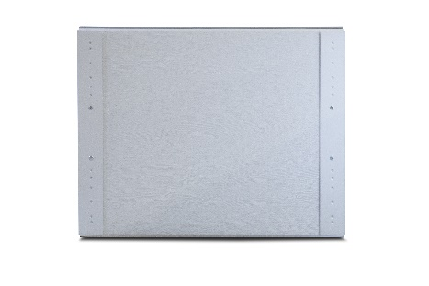

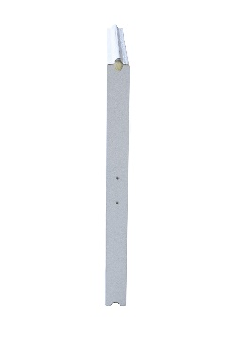

Interior View

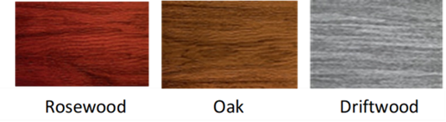

End View

Contact Your Local Dealer