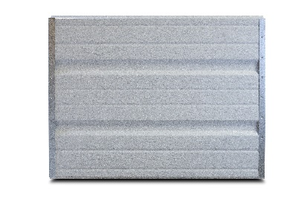

PRODUCT SPECIFCATION SHEET

**SERIES STANDARD FEATURES**

* Heavy Duty construction
* Tog-L-Loc fastening construction
* Deep ribbed panel design
* 20 gauge galvanized end stiles
* Commercial hardware
* 10 ball steel rollers
* 2” or 3” bracket mounted track
* Torsion spring counterbalance
* Inside slide bolt locks
* Aluminum & vinyl loop weather seal
* 10 year limited warranty

**MODEL FEATURES**

* 25 gauge steel skin
* Embossed wood grain texture
* 2” Thick Sections
* Tongue & Groove meeting joints
* Sizes up to 18’-2” wide & 14’ high
* White Interior

*COMMERCIAL SERIES*

**MODEL 260 DEEP RIBBED STEEL GARAGE DOORS**

**AVAILABLE COLORS**

Interior View

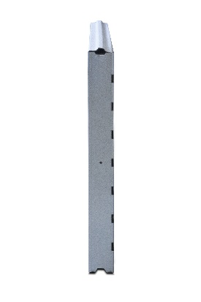

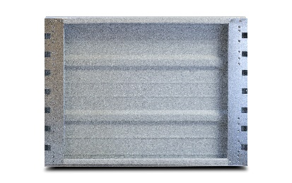

End View



Contact Your Local Dealer

White