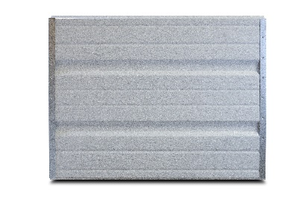

PRODUCT SPECIFCATION SHEET

**SERIES STANDARD FEATURES**

* Heavy Duty construction
* 1-3/8” expanded polystyrene with vinyl backer and R-value = 6
* Tog-L-Loc fastening construction
* Deep ribbed panel design
* 20 gauge galvanized end stiles
* Commercial hardware
* 10 ball steel rollers
* 2” or 3” bracket mounted track
* Torsion spring counterbalance
* Inside slide bolt locks
* Aluminum & vinyl loop weather seal
* 10 year limited warranty

**MODEL FEATURES**

* 24 gauge steel skin
* Smooth texture
* 2” Thick Sections
* Tongue & Groove meeting joints
* Sizes up to 30’-2” wide & 18’ high
* White Interior

*COMMERCIAL SERIES*

**MODEL 241 DEEP RIBBED STEEL GARAGE DOORS**

**AVAILABLE COLORS**

Interior View



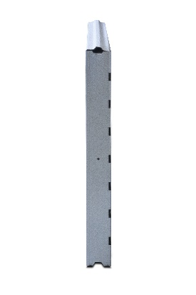

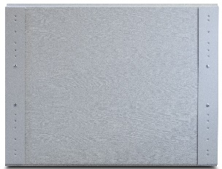

End View



Contact Your Local Dealer

White Brown